OO QUIZ

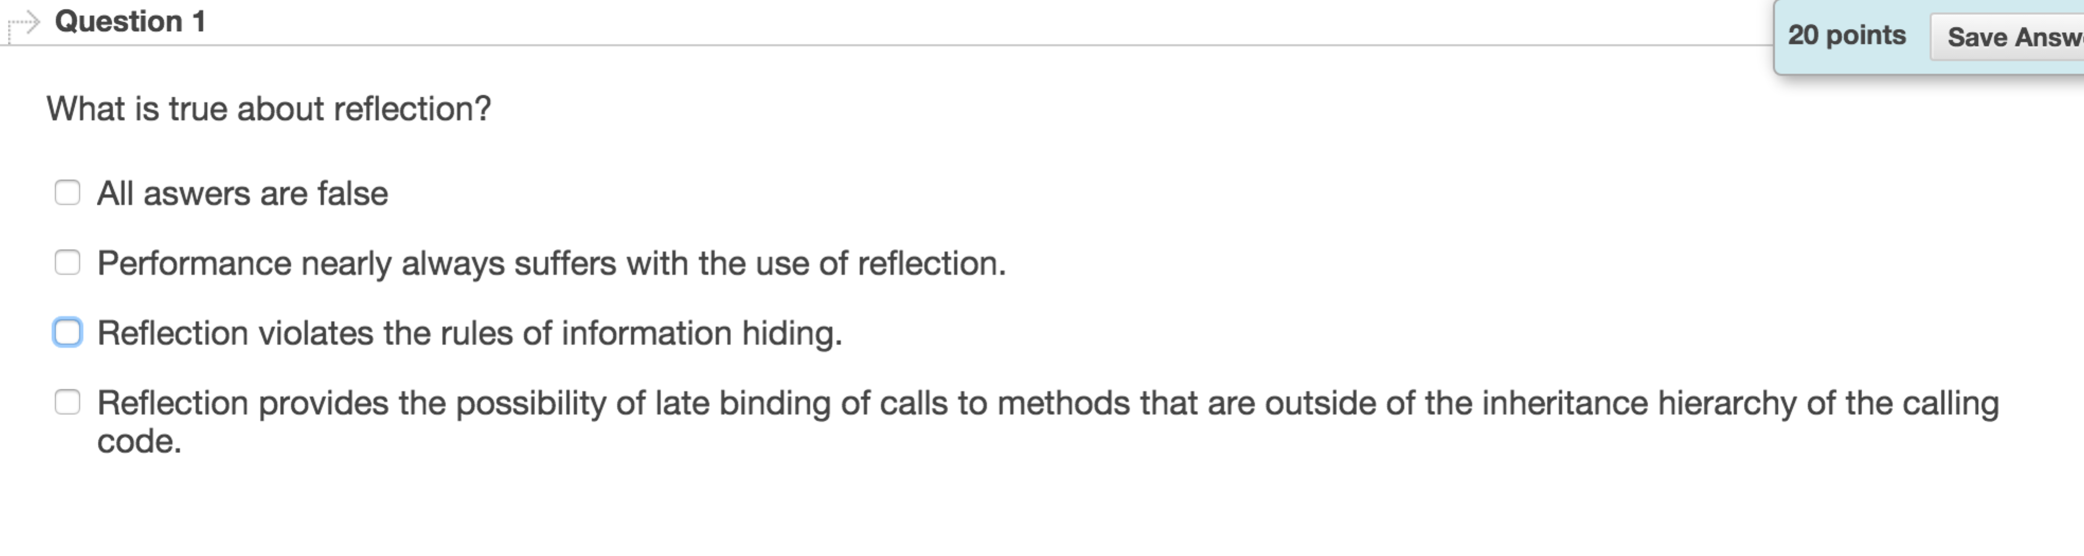

bcd

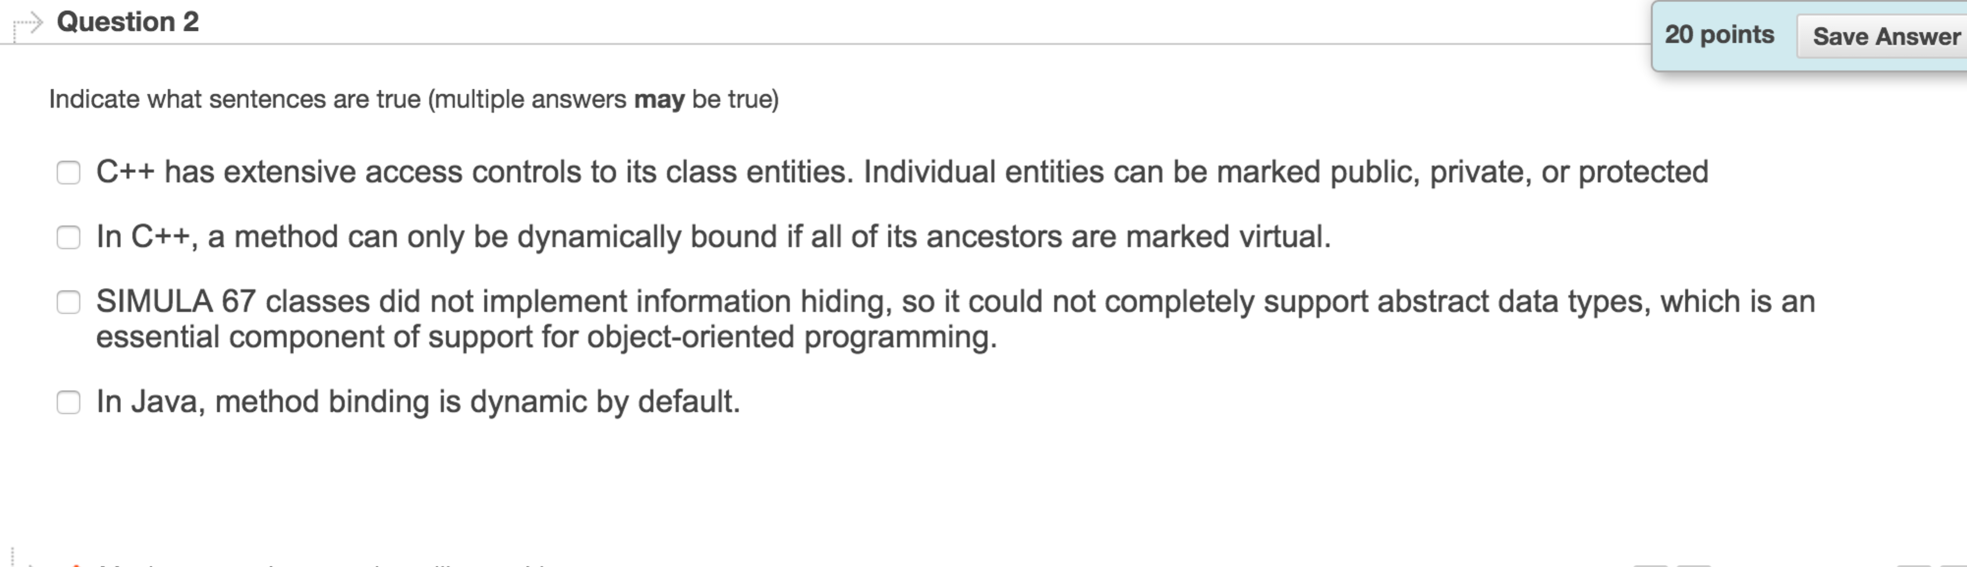

abcd C may not right 答案是ABCD但是老师说C不对

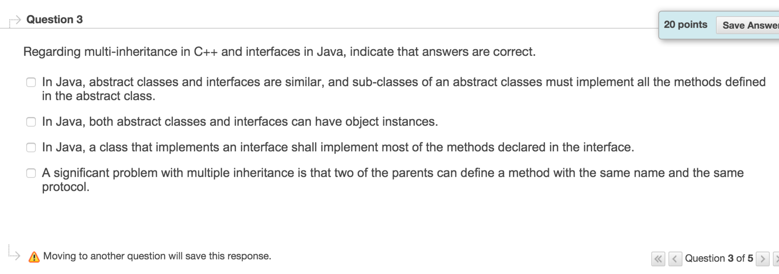

d

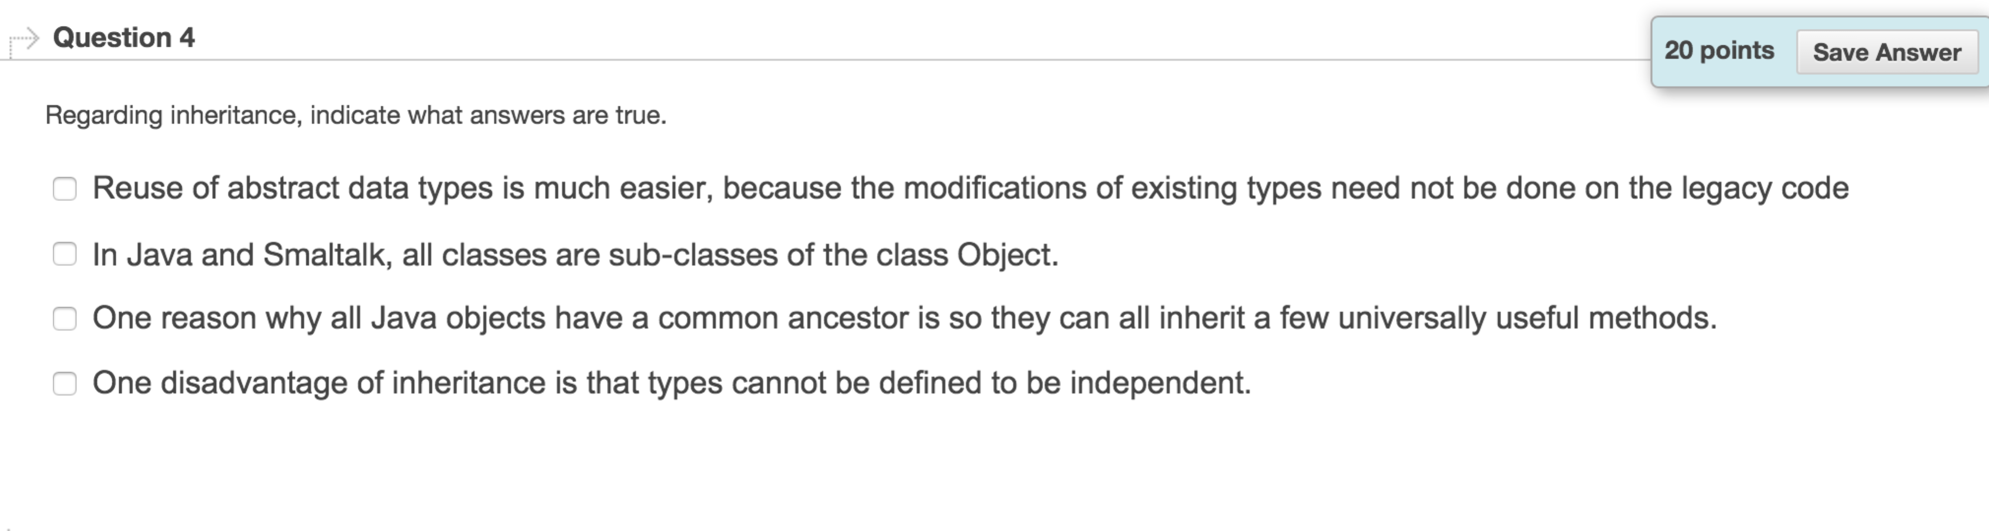

acd

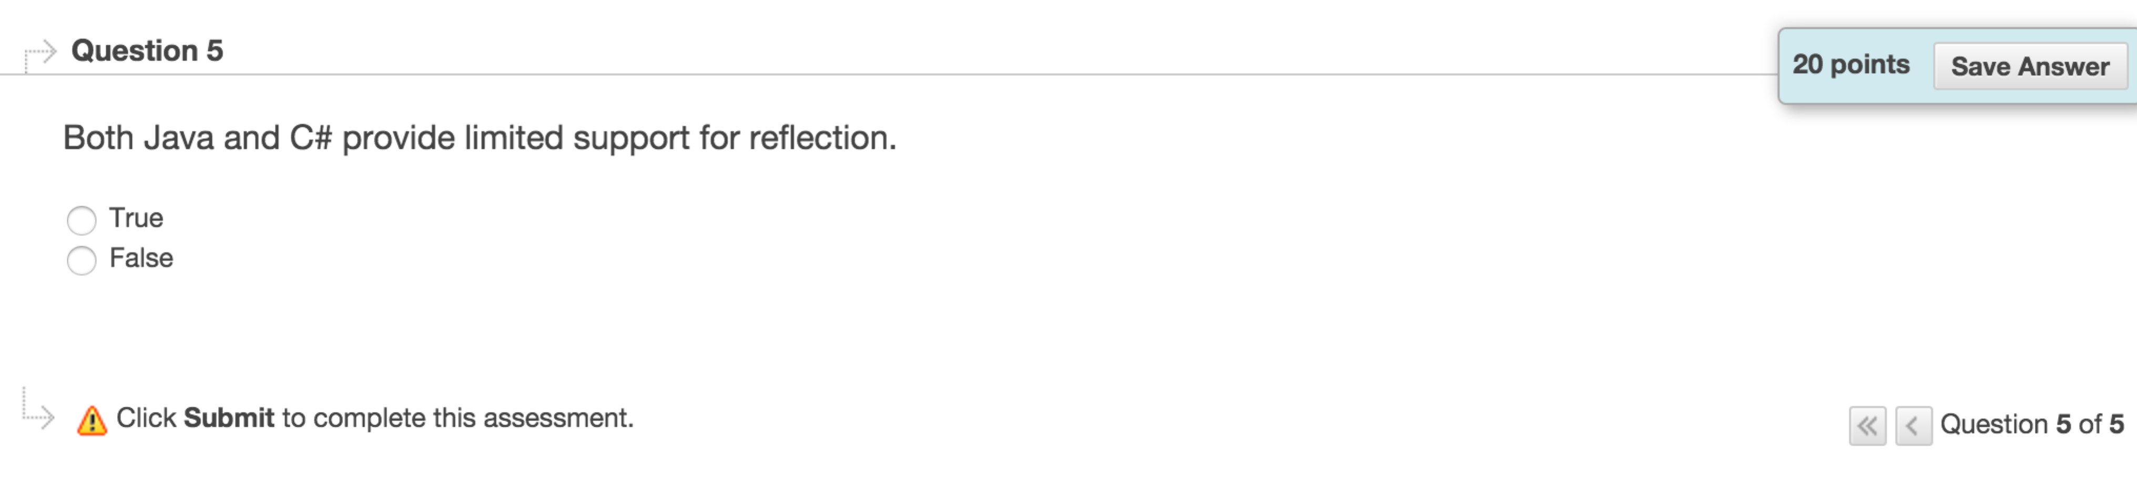true

c++ doesn’t provide it